

**Tribhuvan University**

**Faculty of Humanities and Social Sciences**

**A PROJECT REPORT**

**On**

**Face Attendance System**

**Submitted to**

**Department of Computer Application**

**NIMS College**

***In partial fulfillment of the requirements for the Bachelors in Computer Application***

Submitted by

Raj Kumar Karki

Reg. No. : 6-2-756-8-2019

2024/11

**Under the Supervision of**

**Nirmala Timilsena**



**Tribhuvan University**

**Faculty of Humanities and Social Sciences**

**NIMS College**

**Supervisor’s Recommendation**

I hereby recommend that this project prepared under my supervision by Raj Kumar Karki entitled “**Face Attendance System”** in partial fulfillment of the requirements for the degree of Bachelor of Computer Application is recommended for the final evaluation.

----------------------------

**SIGNATURE**

**Nirmala Timilsena**

**SUPERVISOR**

BCA Department

Kanibahal, Lalitpur, Nepal



**Tribhuvan University**

**Faculty of Humanities and Social Sciences**

**NIMS College**

**LETTER OF APPROVAL**

This is to certify that this project prepared by Raj Kumar Karki entitled “**Face Attendance System”** in partial fulfillment of the requirements for the degree of Bachelor in Computer Application has been evaluated. In our opinion it is satisfactory in the scope and quality as a project for the required degree.

|  |  |
| --- | --- |
|  |  |
| **SIGNATURE of Supervisor** | **SIGNATURE of HOD/ Coordinator** |
| Nirmala Timilsena  Supervisor | Shyam Kumar Thapa  Coordinator |
| Nims College | Nims College |
| Kanibahal Lalitpur, Nepal | Kanibahal Lalitpur, Nepal |
|  |  |
| Signature | Signature |
| **Internal Examiner** | **External Examiner** |

# Abstract

We are living in a world where everything is automated and linked online. The internet of things, image processing, and machine learning are evolving day by day. Many systems have been completely changed due to this evolve to achieve more accurate results. The attendance system is a typical example of this transition, starting from the traditional signature on a paper sheet to face recognition.This Project proposes a method of developing a comprehensive embedded class attendance system using facial recognition with showing whether the face of the person is the students for the specified class or not. The system is based on the machine learning algorithm which is to be implemented on python language and using computer/laptop camera for the input image of the students or a normal outer camera can also be used which has to be connected to the system which is programmed to handle the face recognition by implementing the Local Binary Patterns algorithm LBPHs.

***Keyword: Attendance, Face,*** ***Recognize, Machine learning, LBPHs***

# 

# Acknowledgement

This project was successful with the help of many people. So, I would like to thank all those who helped me to complete this project.

Firstly, I would like to express my special thanks of gratitude to **TU (Tribhuvan University)** and **NIMS** **college** who gave me the golden opportunity to do this project on the topic **Face Attendance system**. I will thank Teacher (**Nirmala Timilsena**) under whose guidance I have learned a lot about this project and developed an excellent project. Her suggestions and directions have helped me a lot to complete this project. She motivated and corrected me while I have errors in my projects. She helped me in doing a lot of Research and i came to know about a lot of things related to this topic.

# Table of Contents

**[Abstract I](#_Toc10020)**

**[Acknowledgement II](#_Toc717)**

**[Table of Contents III](#_Toc26888)**

**[List of Abbreviations V](#_Toc2209)**

**[List of Figures VI](#_Toc14627)**

**[List of Tables VII](#_Toc10023)**

**[Chapter 1: Introduction 1](#_Toc5677)**

[1.1. Introduction 1](#_Toc14038)

[1.2. Problem Statement 2](#_Toc217)

[1.3. Objectives 2](#_Toc32584)

[1.4. Scope and Limitation 3](#_Toc3396)

[1.5. Development Methodology 4](#_Toc11112)

[1.6. Report Organization 6](#_Toc3301)

**[Chapter 2: Background Study and Literature Review 8](#_Toc14368)**

[2.1. Background Study 8](#_Toc32011)

[2.2. Literature Review 9](#_Toc31080)

**[Chapter 3: System Analysis and Design 12](#_Toc1571)**

[3.1. System Analysis 12](#_Toc28905)

[3.1.1. Requirement Analysis 12](#_Toc31329)

[i. Functional Requirements 12](#_Toc19085)

[Use Case Diagram 12](#_Toc30336)

[ii. Non-Functional Requirements 14](#_Toc14000)

[3.1.2. Feasibility Analysis 14](#_Toc7606)

[i. Technical 14](#_Toc22230)

[ii. Operational 15](#_Toc29197)

[iii. Economic 15](#_Toc22801)

[iv. Schedule 15](#_Toc5312)

[3.1.3. Object Modelling using class and Object Diagrams 17](#_Toc32625)

[3.1.4. Dynamic Modelling using State and Sequence Diagram 19](#_Toc22098)

[3.1.5. Process Modelling using Activity Diagrams 20](#_Toc31810)

[3.2. System Design 21](#_Toc31855)

[3.2.1. Refinement of Class, Object, State, Sequence and Activity diagrams 21](#_Toc4316)

[3.2.2. Component Diagrams 22](#_Toc5092)

[3.2.3. Deployment Diagrams 23](#_Toc3155)

[3.3. Algorithm Details 23](#_Toc5924)

**[Chapter 4: Implementation and Testing 26](#_Toc28746)**

[4.1. Implementation 26](#_Toc13882)

[4.1.1. Tools Used (CASE tools, Programming languages, Database platforms) 26](#_Toc30131)

[4.1.2. Implementation Details of Modules (Description of procedures/functions) 29](#_Toc13086)

[4.2. Testing 31](#_Toc14408)

[4.2.1. Test cases for Unit Testing 31](#_Toc7612)

[4.2.2. Test cases for System Testing 32](#_Toc18167)

[4.3. Result Analysis 33](#_Toc21812)

**[Chapter 5: Conclusion and Future Recommendations 35](#_Toc2208)**

[5.1. Conclusion 35](#_Toc8221)

[5.2. Future Recommendations 35](#_Toc8151)

**[Appendices 36](#_Toc31690)**

**[References 43](#_Toc3454)**

[Bibliography 44](#_Toc747)

# List of Abbreviations

**Table 1****: List of Abbreviation**

|  |  |
| --- | --- |
| **Abbreviations** | **Full Form** |
| CRUD | Create Read Update Delete |
| DBMS | Database Management System |
| LBPH | Local Binary Patterns Histogram |
| PCA | Principal Component Analysis |
| SDLC | Software Development Life Cycle |
| SQL | Structured Query Language |
| TU | Tribhuvan University |
| UI | User Interface |

# 

# 

# List of Figures

[Figure 1: Chapter 1.3 Objectives 3](#_Toc7809)

[Figure 2: Chapter 1.5 Waterfall Methodology 4](#_Toc20481)

[Figure 3: Chapter 3.1.1 Use case 13](#_Toc9382)

[Figure 4: Chapter 3.1.2 Schedule\_Gantt chart 16](#_Toc13499)

[Figure 5: Chapter 3.1.3 Object Modelling 17](#_Toc15902)

[Figure 6: Chapter 3.1.4 Dynamic Modelling 19](#_Toc2564)

[Figure 7: Chapter 3.1.5 Process Modelling 20](#_Toc28501)

[Figure 8: Chapter 3.2.2 Component Diagram 22](#_Toc8388)

[Figure 9: Chapter 3.2.3 Deployment Diagram 23](#_Toc29438)

[Figure 10: Chapter 3.3 LBPH Algorithm 25](#_Toc26795)

[Figure 11: Chapter 4.3 Data\_Image 33](#_Toc8536)

[Figure 12: Chapter 4.3 Train\_Image 33](#_Toc13837)

[Figure 13: Chapter 4.3 Train\_Image\_Showing 34](#_Toc7587)

# List of Tables

[Table 1: List of Abbreviation V](#_Toc2962)

[Table 3: Chapter 4.1.1 CASE tools 26](#_Toc30974)

[Table 4: Chapter: 4.1.1 Programming tools 28](#_Toc24425)

[Table 5: Chapter: 4.1.1 Database Platforms 29](#_Toc27285)

[Table 6: Chapter 4.2.1 Unit testing 31](#_Toc5173)

[Table 7: Chapter 4.2.2 System testing 32](#_Toc25242)

# Chapter 1: Introduction

## 1.1. Introduction

Attendance system is the system which is use to shows the present of the people in a work. It is very important in every work because it help to manage and make everything in a proper system balance. In order it can be said as the record of the available of the people according to the date, time or day, months, etc.

The management of attendance in many settings has been transformed by technological improvements in recent years, along with many other parts of our life. One such invention is the face recognition-based attendance system, which accurately and effectively tracks and records attendance by using state-of-the-art facial recognition algorithms.

Historically, keeping track of attendance has been a laborious, manual procedure that is prone to manipulation. Face recognition technology, on the other hand, has given corporations, educational institutions, and organizations from many industries a more dependable and automated option. The face recognition-based attendance system functions by identifying and analyzing each person's distinctive facial traits. To identify and match facial patterns with previously collected data, it combines cameras, sensors, and sophisticated algorithms.

Using this technique, people may be accurately identified in real-time, not requiring physical cards, passwords, or signatures. To maintain the attendance record with day-to-day activities is a challenging task. The conventional method of calling name of each student is time consuming and there is always a chance of proxy attendance. The following system is based on face recognition to maintain the attendance record of students. The daily attendance of students is recorded subject wise which is stored already by the administrator. As the time for corresponding subject arrives the system automatically starts taking snaps and then apply face detection and recognition technique to the given image and the recognize students are marked as present and their attendance update with corresponding time and subject id.

We have used deep learning techniques to develop this system, histogram of oriented gradient method is used to detect faces in images and deep learning method is used to compute and compare feature facial of students to recognize them. Our system is capable to identify multiple faces in real time. The main objective of this project is to develop face recognition based automated student attendance system. In order to achieve better performance, the test images and training images of this proposed approach are limited to frontal and upright facial images that consist of a single face only. The test images and training images have to be captured by using the same device to ensure no quality difference. In addition, the students have to register in the database to be recognized. The enrolment can be done on the spot through the user-friendly interface.

## 1.2. Problem Statement

Traditional student attendance marking technique is often facing a lot of trouble. The face recognition student attendance system emphasizes its simplicity by eliminating classical student attendance marking technique such as calling student names or checking respective identification cards. There are not only disturbing the teaching process but also causes distraction for students during exam sessions. Apart from calling names, attendance sheet is passed around the classroom during the lecture sessions. The lecture class especially the class with a large number of students might find it difficult to have the attendance sheet being passed around the class.

**Solution**

Thus, face recognition student attendance system is proposed in order to replace the manual signing of the presence of students which are burdensome and causes students get distracted in order to sign for their attendance. Furthermore, the face recognition based automated student attendance system able to overcome the problem of fraudulent approach and lecturers does not have to count the number of students several times to ensure the presence of the students.

## 1.3. Objectives

It provides flexibility and reduces the time loss. There will be no chance for a proxy. The objective of this project is to develop face recognition based automated student attendance system. Expected achievements in order to fulfill the objectives are:

1. To detect the face segment from the video frame.
2. To classify the features in order to recognize the face detected.
3. To record the attendance of the identified student.
4. To mark the attendance.

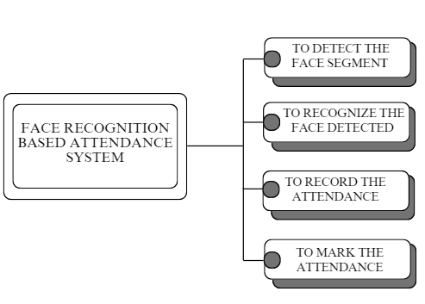

**Figure 1: Chapter 1.3 Objectives**

## 1.4. Scope and Limitation

The scope of face recognition based attendance system is that only teachers can use it as different subject teacher. They have to login to register or have to ask teachers who have the access. Once they login, they can access the system. It saves the information of the students by their name, id, mobile number, roll no, photos, email and their attendance. It has the features of taking attendance by capturing student’s face and auto attendance. This features will help the teacher to take attendance. It is quite easy to use and does not required well skilled. If teachers forget the password they can simply reset password by click on forget password but have to answer the questions.

The limitation of face recognition based attendance system project is that the teachers have to take student’s attendance one by one looking in front of camera. It does detect multi faces at once. faces should be clearly seen in camera otherwise it will display unknown.

## 1.5. Development Methodology

Waterfall methodology is used in this project. They are four phases in this project. They are System analysis, system Design, Implementation and Testing which is shown in the figure below. [[5]](#five)

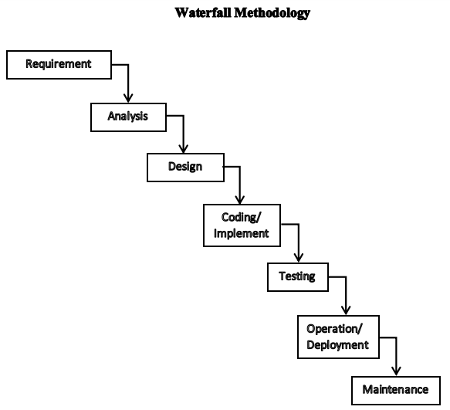

**Figure 2: Chapter 1.5 Waterfall Methodology**

In this project, waterfall model is used for the face recognition based attendance system development.

1. **Requirements Gathering:**

* The need for face recognition (e.g., to automate attendance).
* Expected accuracy levels.
* Hardware requirements (camera, processing power).
* Integration with existing systems (e.g., databases).

1. **System Design:**

* Face detection module.
* Feature extraction (face recognition) module.
* Database for storing student information.
* Plan the overall system flow.

1. **Implementation:**

* Implement face detection algorithms (e.g., Haar cascades).
* Train face recognition models (e.g. LBPH).
* Set up the database for student records.
* Integrate components.

1. **Testing:**

* Conduct unit testing for individual modules.
* Perform integration testing to ensure seamless communication between components.
* Validate face recognition accuracy using test images.

1. **Deployment:**

* Deploy the system in the target environment (e.g. classroom).
* Set up cameras and necessary hardware.
* Configure the system to capture real-time images.

1. **Maintenance:**

* Provide ongoing support for system users.
* Address any issues or enhancements.
* Update face recognition models periodically.

## 1.6. Report Organization

**Chapter 1 Introduction**

This chapter provides an overview of the research project. It introduces the problem statement, the objectives of the study, and the development methodology. It also outlines the structure of the report and provides a brief summary of each subsequent chapter.

**Chapter 2 Background Study and Literature Review**

In this chapter, a comprehensive review of relevant literature is presented. It explores existing research, technologies, and methodologies related to Face Attendance Systems. The chapter discusses various approaches, their strengths, weaknesses, and gaps in the field, providing a foundation for the current study.

**Chapter 3 System Analysis and Design**

This chapter delves into the analysis of requirements and design considerations for the Face Attendance Systems. It outlines the system's functional and non-functional requirements, user needs, and potential challenges. The design phase covers the architecture, components, and algorithms chosen for the system, detailing how they will address the identified requirements.

**Chapter 4 Implementation and Testing**

Here, the practical implementation of the Face Attendance Systems is described. The chapter covers the development process, coding practices, and technologies used to bring the system to life. It discusses the testing methodologies employed, including unit testing, and system testing, to validate the system's performance and accuracy.

**Chapter 5 Conclusion and Future Recommendations**

The final chapter wraps up the report by summarizing the findings and outcomes of the research. It discusses the achievements, challenges, and limitations encountered during the project. Additionally, this chapter provides insights into potential future enhancements,

recommendations for refining the system's accuracy and usability, and its applicability to real-world scenarios.

Overall, the report follows a logical structure that takes the reader through the journey of the research project, from the initial introduction to the final conclusions and suggestions for future work. Each chapter contributes to building a comprehensive understanding of Face Attendance Systems and its significance in the context of education and technology.

# Chapter 2: Background Study and Literature Review

## 2.1. Background Study

Attendance management has come a long way from traditional paper-based methods to advanced digital solutions that streamline and automate the process. Over the years, technological advancements have revolutionized how organizations track and manage employee attendance. In this blog, we’ll explore the three generations of attendance management, leading up to the cutting-edge Tempus Central—and [automated attendance management software](https://tempuscentral.com/) that has taken the industry by storm.

**1st Generation:**

Paper-Based Attendance Management In the early days, attendance management relied heavily on manual processes involving pen and paper. Employees would sign in on a physical attendance sheet, and HR personnel would painstakingly record and tally the data. This method was not only time-consuming but also prone to errors. Organizations faced challenges in maintaining the accuracy of records, especially as the workforce grew. Additionally, managing attendance data in physical files made it difficult to access and analyze the information efficiently.

**2nd Generation:**

Biometric Devices and Excel-Based Attendance Management With technological progress, the second generation saw the introduction of biometric devices like fingerprint scanners and facial recognition systems. These biometric solutions provided a more reliable way to record employee attendance and reduced the possibility of time theft and buddy punching. However, despite the improvement, the data was still managed using Excel spreadsheets or basic software. While this digitized the process to some extent, HR departments still struggled to handle different sheets for various departments, leading to potential discrepancies.

**3rd Generation:**

[Attendance Software-Based Attendance Management](https://tempuscentral.com/) As businesses recognized the need for more sophisticated solutions, the third generation of attendance management arrived with specialized attendance software. These software solutions allowed organizations to centralize attendance data, making it easily accessible and manageable. Employees could punch in and out using biometric devices, swipe cards, or even mobile apps, ensuring accurate attendance records. HR teams benefited from real-time insights into attendance patterns, enabling them to address attendance-related issues promptly.

Later on Tempus Central was introduce for the attendance. The [Automated Attendance Management Software](https://tempuscentral.com/) Revolution Tempus Central marks the most revolutionary generation of attendance management. This all-in-one automated software offers seamless attendance tracking and management, integrated with a comprehensive payroll system. With Tempus Central, there’s [no need to manage multiple Excel sheets](https://www.youtube.com/watch?v=4uOnXvG5nEA) or shuffle between various platforms for attendance and payroll. The software streamlines the entire process, ensuring accuracy, efficiency, and significant time savings for HR teams. [[7]](#seven)

## 2.2. Literature Review

A literature review is a compilation, classification, and evaluation of what other researchers have written on a particular topic. A literature review normally forms part of a research thesis but it can also stand alone as a self-contained review of writings on a subject.

**Case 1**

According to the research journal “RFID based Student Attendance System” (Hussain, Dugar, Deka, Hannan, 2014), the proposed solution is almost similar to the first research journal where RFID technology is used to improve the older attendance system. In this system, a tag and a reader is again used as a method of tracking the attendance of the students. The difference between the first journals with this is where attendance‟s information can be accessed through a web portal. It provides more convenient for information retrieval. Again, this system is imperfect in the sense that, firstly, it is not portable, as the RFID reader can only work when it is connected to a PC. Secondly, the RFID tag is not a guanine information that can uniquely identify a student, thus, resulting in the inaccuracy of the collected attendance information. [[1]](#one)

**Case 2**

The second research journals “Face Recognition Based Attendance Marking System” (Senthamil Selvi, Chitrakala, Antony Jenitha, 2014) is based on the identification of face recognition to solve the previous attendance system‟s issues. This system uses camera to capture the images of the employee to do face detection and recognition. The captured image is compared one by one with the face database to search for the worker‟s face where attendance will be marked when a result is found in the face database. The main advantage of this system is where attendance is marked on the server which is highly secure where no one can mark the attendance of other. Moreover, in this proposed system, the face detection algorithm is improved by using the skin classification technique to increase the accuracy of the detection process. Although more efforts are invested in the accuracy of the face detection algorithm, the system is yet not portable. This system requires a standalone computer which will need a constant power supply that makes it not portable. This type of system is only suitable for marking staff‟s attendance as they only need to report their presence once a day, unlike students which require to report their attendance at every class on a particular day, it will be inconvenient if the attendance marking system is not portable. Thus, to solve this issue, the whole attendance management system can be developed on an portable module so that it can be work just by executing the python program. [[2]](#two)

**Case 3**

The Third research journal “Attendance System Using NFC (Near Field Communication) Technology with Embedded Camera on Mobile Device” (Bhise, Khichi, Korde, Lokare, 2015). The attendance system is improved by using NFC technology and mobile application. According to the research paper, each student is given a NFC tag that has a unique ID during their enrolment into the college. Attendance of each class will then be taken by touching or moving these tags on the lecturer mobile phone. The embedded camera on the phone will then capture the student‟s face to send all the data to the college server to do validation and verification. The advantages of this method is where the NFC is simple to use, and the speed of connection establishment is very high. It indeed speeds up the attendance taking process a lot. However, this system could not automatically spot the violation when the NFC tag is not personally tagged by the original owner. Apart from that, the convenience of the system which uses the mobile phone as the NFC reader was actually an inconvenience to the lecturer. Imagine if the lecturer had forgotten to bring their mobile phones to work, what would be the backup procedure for the attendance to be recorded? Moreover, most of the lecturer will not likely to prefer their personal smart phones to be used in this way due to privacy matter. Hence, unique information about the student like biometric or face recognition, which is guanine for a student should be used in replacement of the NFC tag. This will ensure attendance to be taken originally by the actual student. [[3]](#three)

**Case 4**

The Fourth research journal “Fingerprint Based Attendance System Using Microcontroller and LabView” (Kumar Yadav, Singh, Pujari, Mishra, 2015) proposed a solution of using fingerprint to mark the attendance. This system is using 2 microcontrollers to deal with the fingerprint recognition process. Firstly, the fingerprint pattern will be obtained through a fingerprint sensor, then the information will be transmitted to microcontroller 1. Next microcontroller 1 will pass the information to microcontroller 2 to do the checking with the database that resides in it. After finding a student‟s match, the details are sent to the PC through serial communication to be displayed. This design is good as it accelerates development while maintaining design flexibility and simplifies testing. But again, this system is attached to a PC which make it not portable. Other than that, the database information cannot be accessible easily. Meaning that, for the parents whom are interested in knowing their child‟s attendance cannot easily or conveniently access the information. Therefore, to provide accessibility of the student‟s information to the legitimate concerned party, the information can be uploaded to a web server for easy access. While the authentication for the appropriate access can be enforced through a login screen. [[4]](#four)

In conclusion, a better attendance monitoring system should be developed based on its portability, accessibility and the accuracy of the collected attendance information.

# Chapter 3: System Analysis and Design

All the students of the class must be registered by administrator by entering the required details and then their images will be captured and stored in the datasets. During each session, faces will be detected from live streaming video of classroom. The faces detected will be compared with images present in the datasets. If match found, attendance will be marked for the respective student.

## 3.1. System Analysis

The process of gathering information on certain topic through interviews, surveys, etc is called Requirement identification. It is the first stage of collecting data. It includes the study of existing system and literature reviews which shows how the system works and why it is needed.

### 3.1.1. Requirement Analysis

The process of identifying and categorizing the requirements for a system is called requirement analysis. The purpose of this step in the software development life cycle (SDLC) is to ensure that all stakeholders have clear, shared understanding about what the system should do or achieve. This includes defining functional and non-functional requirements as well as prioritizing them based on their importance and urgency.

#### **Functional Requirements**

1. Faces on an image must be detected.
2. Compute the total attendance based on detected faces.
3. Store the cropped faces in a folder.
4. Train faces for recognition.
5. Display the name and ID of the output image down the image in the plot area.

#### Use Case Diagram

The Use Case Model describes the proposed functionality of the new system. A Use Case represents a discrete unit of interaction between a user (human or machine) and the system. A Use Case is a single unit of meaningful work. For example login to system, register with system and create order are all Use Cases. Each Use Case has a description which describes the functionality that will be built in the proposed system. A Use Case may 'includes' another Use Case's functionality or 'extends' another Use Case with its own behavior.

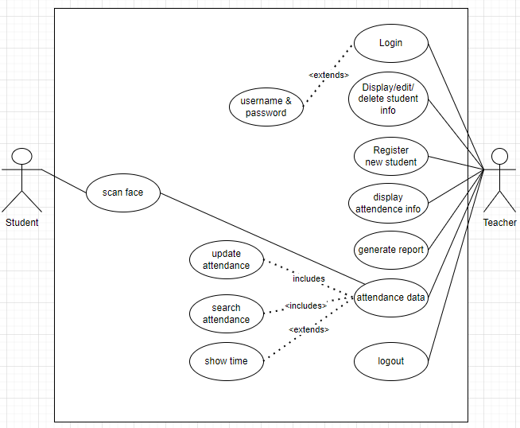

**Figure** **3: Chapter 3.1.1 Use case**

As above Use Case Diagram show the roles of the two persons as an student and Teacher. Teacher have the authorities to manipulate in the system where student doesn't have authorities. There are many features like display, updating, deleting, login, logout, registration new student, generate report, attendance data, display attendance information and can access the system online. These are mostly required to complete the system.

1. Teacher can add or delete the student from the system as students by their id, name and class section.
2. When Teacher registered the students name as student, student’s face can be use to take attendance in the system.
3. Whenever the teacher have any problems regards update, they can change in the system communicate with teacher about it.
4. If the teacher would like to leave the system from the connect device they would simply need to logout.

#### Non-Functional Requirements

1. The user will inform the students when taking a photo with clear instructions on how to position their faces.
2. The system can detect the face from a live-stream video.
3. The system is reliable because of the advanced technology that is used to develop the system, the system can achieve a face detection accuracy of up to 90%.
4. The system will have a response time of many seconds.

### 3.1.2. Feasibility Analysis

A feasibility study evaluates the project's potential for success. Therefore, perceived objectivity is an important factor in the credibility of the study for potential investors and lending institutions. . It must therefore, be conducted with an objective, unbiased approach to provide information upon which decisions can be based. Here, we discuss 3 major feasibility studies required for our project.

#### Technical

Technical feasibility is carried out to determine whether the project is feasible in terms of software, hardware, personnel, and expertise, to handle the completion of the project. It considers determining resources for the proposed system. As the system is developed using python, it is platform independent. Therefore, the users of the system can have average processing capabilities, running on any platform. The technology is one of the latest hence the system is also technically feasible.

#### Operational

Operational feasibility is the measure of how well a proposed system solves the problems with the users. Operational feasibility is dependent on human resources available for the project and involves projecting whether the system will be used if it is developed and implemented. The project is operationally feasible for the users as nowadays almost all the teachers/staffs are familiar with digital technology.

#### Economic

Economic feasibility defines whether the expected benefit equals or exceeds the expected costs. It is also commonly referred to as cost/benefit analysis. The procedure is to determine the benefits and the savings expected from the system and compare them with the costs. A proposed system is expected to outweigh the costs. This is a small project with no cost for development. The system is easy to understand and use. Therefore, there is no need to spend on training to use the system. This system has the potential to grow by adding functionalities for students as well as teachers. This can Hence, the project could have economic benefits in the future.

#### Schedule

Through this, timeline is develop for the project. It makes quite easier to see the tasks along with time required and how long should be taken to complete it. It also shows the who should be working on it and what order work should be done in. The following Gantt Chart shows the timeline and completion of project along with the starting and ending dates of the project. Gantt chart is a project management tool that illustrates work completed over a period of time in relation to the time planned for the work. A Gantt chart can include the start and end dates of tasks, milestones, dependencies between tasks, assignee, and more.

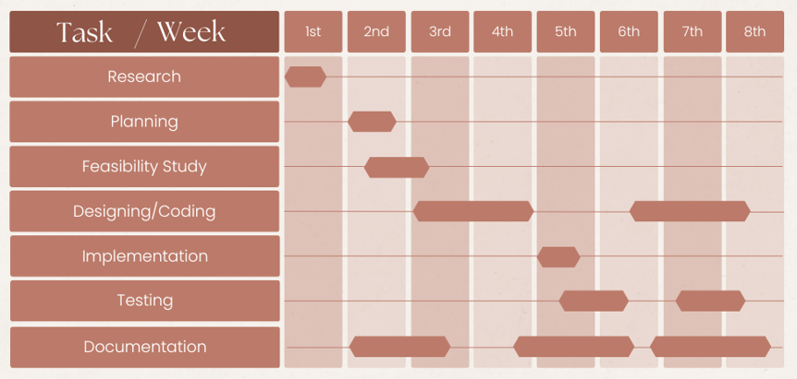

**Figure 4: Chapter 3.1.2 Schedule\_Gantt chart**

On the left of the chart is a list of the activities and along the top is a suitable time scale. Each activity is represented by a bar; the position and length of the bar reflects the start date, duration and end date of the activity.

### 3.1.3. Object Modelling using class and Object Diagrams

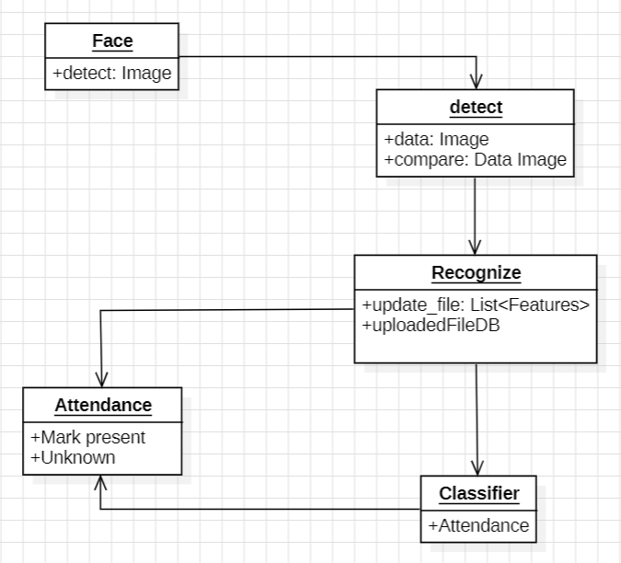

**Figure 5: Chapter 3.1.3 Object Modelling**

The object model for the Face Recognition Attendance System, shown in the class and object diagrams, breaks down the system into five key components: Face, Detect, Recognize, Classifier, and Attendance.

1. **Face Class:** This class is responsible for detecting faces in images. It has a method called `detect` which initiates the face detection process by analyzing the image.
2. **Detect Class:** This class handles the image data and compares it to pre-stored data. It has attributes like `data` for storing the image and `compare` for comparing the detected face with the stored face data.
3. **Recognize Class:** This class takes care of recognizing faces from the detected image. It updates files with recognized features using the `update\_file` method and interacts with the `uploadedFileDB` to manage the database of uploaded files.
4. **Classifier Class:** This class classifies the recognized faces into attendance records. It has an attribute `Attendance` which manages the attendance data once a face is recognized.
5. **Attendance Class:** This class is responsible for marking attendance. It has methods such as `Mark present` and `Unknown` to mark recognized faces as present or unrecognized ones.

The workflow begins with the Face class detecting an image, which is processed by the Detect class. The Recognize class then updates the file with recognized features and interacts with the database. The Classifier class categorizes the recognized faces, and finally, the Attendance class marks the attendance. This model outlines the structure and interaction of the components in the system, providing a clear understanding of how face recognition is used for attendance marking.

### 3.1.4. Dynamic Modelling using State and Sequence Diagram

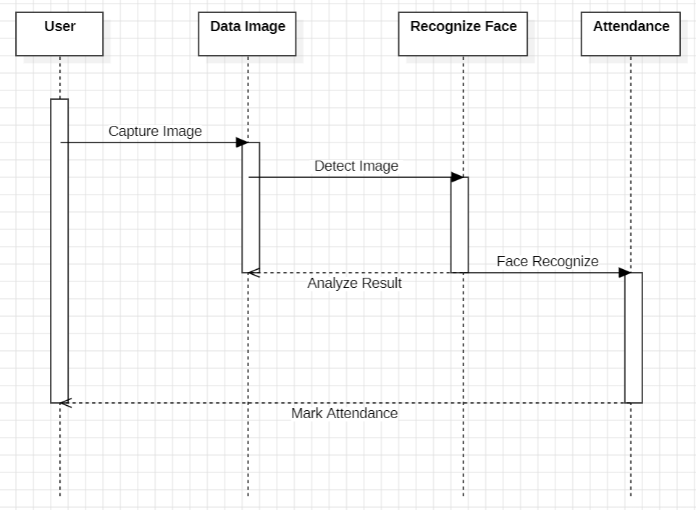

**Figure 6: Chapter 3.1.4 Dynamic Modelling**

The sequence diagram for the Face Recognition Attendance System illustrates the interactions between different components: User, Data Image, Recognize Face, and Attendance. The process begins when the User initiates the capture of an image. This image is sent to the Data Image component for detection. Once the image is detected, it moves to the Recognize Face component, which performs face recognition. The result of the face recognition is then analyzed and sent to the Attendance component to mark attendance. Finally, the User is notified that their attendance has been recorded. This diagram effectively represents the work flow of the system, showcasing how various components interact to achieve the goal of marking attendance using face recognition technology.

### 3.1.5. Process Modelling using Activity Diagrams

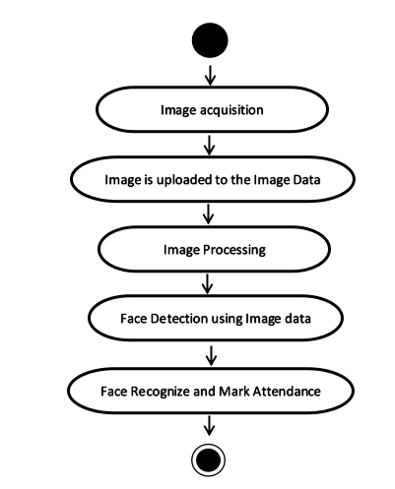

**Figure 7: Chapter 3.1.5 Process Modelling**

The activity diagram for the Face Recognition Attendance System shows the steps involved in recording attendance. It starts with the teacher taking a student's picture. The image is then uploaded to an image data repository. Next, the image goes through processing, where the system detects the face using the uploaded image data. Once the face is detected, the system recognizes the student and marks their attendance. This diagram helps visualize the step-by-step process of automating attendance using face recognition technology, making it easier to understand how each part of the system works together to achieve the goal.

## 

## **3.2. System Design**

### 3.2.1. Refinement of Class, Object, State, Sequence and Activity diagrams

1. **Class Diagram Refinement**

The class diagram refinement involves adding more details to each class, such as specific attributes and methods. The `FaceRecognitionSystem` class could have additional methods like `trainModel()` and `updateDatabase()`, and attributes such as `modelPath` and `trainingData`. This provides a clearer structure and a more comprehensive understanding of how each class functions within the system.

1. **Object Diagram Refinement**

The object diagram refinement includes specifying the states and attributes of objects at a particular point in time. For instance, an object of the `Student` class might have its `studentId` set to "12345" and `name` as "Raj Kumar", with specific face encodings stored in an array i.e, number of students, id and photo. This helps to visualize the instances of classes and their relationships more effectively.

1. **State Diagram Refinement**

Refining the state diagram involves adding detailed transitions and possible errors between states. For the Face Recognition Attendance System, states such as `Idle`, `FaceDetected`, `RecognizingFace`, and `AttendanceMarked` can be included, with transitions showing events like `StartRecognition` and `RecognitionFailed`. This allows for a more detailed understanding of the system's behavior and response to different events.

1. **Sequence Diagram Refinement**

The sequence diagram refinement adds more specific interactions and sequences of events. It can detail the interaction between the user interface and the face recognition module, including asynchronous calls and error handling. This ensures that the sequence of operations is clearly defined and can handle various scenarios effectively.

1. **Activity Diagram Refinement**

Refining the activity diagram involves adding decision points and parallel processes. In the Face Recognition Attendance System, activities like `CaptureImage`, `DetectFace`, `RecognizeFace`, and `MarkAttendance` can be detailed with decision points such as `FaceDetected?` and parallel activities like processing multiple images simultaneously. This provides a clear workflow and highlights all possible paths and actions within the system.

### 3.2.2. Component Diagrams

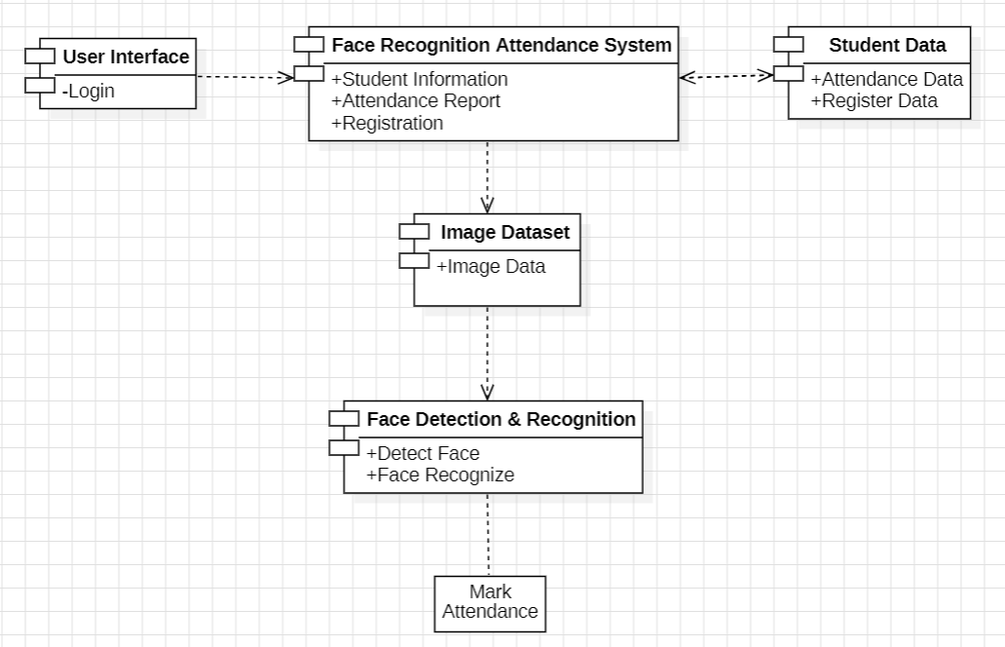

**Figure 8: Chapter 3.2.2 Component Diagram**

The component diagram for the Face Recognition Attendance System shows how different parts of the system interact with each other. The main component is the "Face Recognition Attendance System," which handles student information, attendance reports, and registration. This system interacts with the "User Interface" for login purposes and the "Student Data" component, which manages attendance and registration data. The "Face Recognition Attendance System" also connects to an "Image Dataset" that stores image data. The "Image Dataset" feeds into the "Face Detection & Recognition" component, which is responsible for detecting and recognizing faces. Once a face is recognized, the system marks attendance. This diagram provides a clear overview of how different components work together to achieve automated attendance marking using face recognition technology.

### 3.2.3. Deployment Diagrams

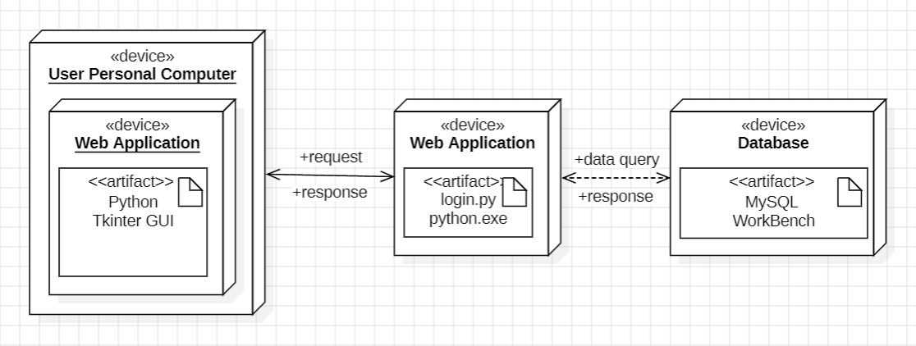

**Figure 9: Chapter 3.2.3 Deployment Diagram**

The deployment diagram for the Face Recognition Attendance System shows how different components and devices interact. It consists of three main parts:

1. **User Personal Computer:** This device hosts a web application with a Python Tkinter GUI. Users interact with this interface to send requests.
2. **Web Application Server:** This server hosts the core web application and processes requests from the user interface. It handles operations like face recognition and communicates with the database server for data.
3. **Database Server:** Managed by MySQL WorkBench, this server stores all the data related to the system. It receives queries from the web application server and returns the necessary data.

The diagram highlights the flow of requests and responses between these components, showing how they work together to make the system function effectively. This helps understand the system architecture and the interactions required for automated attendance marking using face recognition.

## 3.3. Algorithm Details

Face recognition algorithms are made to recognize and verify people based on the characteristics of their faces. I'll give a broad overview of a common face recognition algorithm even though there are many different techniques and algorithms utilized in face recognition systems.

**Proposed Algorithm**

Capture the student’s image through camera.

Detect each and every individual face by apply face detection algorithm.

Extract the ROI(Region Of Interest) in rectangular bounding box.

Converting to gray scale, apply histogram equalization and resize to 100x 100 i.e. apply pre-processing.

If image captured then Store in database Else Apply LBPH (for feature extraction ) Apply SVM( for classification) End if

Post-processing

**Local Binary Patterns Histogram(LBPH) Step- by -step algorithm:**

**Parameters: the LBPH uses 4 parameters**:

**Radius:**

the radius is used to build the circular local binary pattern and represents the radius around the central pixel. It is usually set to 1.

**Neighbour:**

the number of sample points to build the circular local binary pattern. Keep in mind: the more sample points you include, the higher the computational cost. It is usually set to 8.

**Grid X:**

the number of cells in the horizontal direction. The additional cells, the finer the grid, the higher the dimensional of the resulting feature vector. It is usually set to 8.

**Grid Y:**

the number of cells in the vertical direction. The more cells, the finer the grid, the higher the dimensional of the resulting feature vector.

**Training the Algorithm:**

First, we need to train the algorithm. To do so, we need to use a datasets with the facial images of the people we want to recognize. We need to also set an ID (it may be a number or the name of the person) for each image, so the algorithm will use this information to recognize an input image and give you an output. Images of the same person must have the same ID.

**Applying the LBP operation:**

The first computational step of the LBPH is to create a intermediate image that describes the original image in a better way, by highlighting the facial characteristics. To do so, the algorithm uses a concept of a sliding window, based on the parameter’s radius and neighbour.

**Extracting the Histograms:**

Now, using the image generated in the last step, we can use the Grid X and Grid Y parameters to divide the image into multiple grids. [[6]](#six)

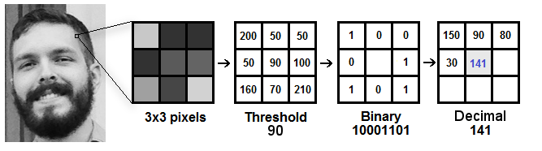

**Figure 10: Chapter 3.3 LBPH Algorithm**

# Chapter 4: Implementation and Testing

## 4.1. Implementation

### 4.1.1. Tools Used (CASE tools, Programming languages, Database platforms)

**CASE Tools**

**Table 3: Chapter 4.1.1 CASE tools**

|  |  |
| --- | --- |
| **Used for** | **Tools and technologies** |
| Analysis Tools |  |
| Design Tools | balasamiq  IMG_256 |
| Programming Tools | IMG_256IMG_256IMG_256 |
| Prototyping Tools | balasamiq |
| Maintenance Tools | IMG_256 |
| Diagram Tools | IMG_256 |
| Process Modeling Tools | IMG_256 |
| Project Management Tools | IMG_256 |
| Documentation Tools | wps |
| Configuration Management Tools | wps |
| Change Control Tools | IMG_256wpsIMG_256 |
| Web Development Tools | IMG_256chrome IMG_256 explorer IMG_256 |
| Quality Assurance Tools | wps |

**XMind**

XMind is a software in which I have design the objective diagrams.

**StarUML**

StarUML is a modular and open tool which provides frameworks for extending the functionality of the tools. With the help of StarUML, I designed the project’s Figure like Flow-charts, Use-Case diagram, DFD, etc.

**Vs Code**

Visual Studio Code is a free, lightweight but powerful source code editor. I coded my project using python language in Vs code. This help me to develop and run my project.

**Balasamiq cloud**

Balasamiq Cloud is a web-based which help me to creates wireframe. I design my project UI using this web for prototype.

**WPS Office**

WPS Office is a free office software in which i made documentation of my project as doc file and convert it into pdf file.

**YouTube**

Using Youtube, I search about the project and code “what to develop”, “how to develop”, etc.

**Chrome**

I used chrome for download the python language, opencv, vs code, and search for the code as well. I search for the code from git-hub and used w3school for help to understand the error that came in my project.

**Microsoft Edge**

Microsoft edge has got the co-pilot features for free. So, I used it as code fixers and QA (Quality Assurance) of my project code. Whenever I face error in code. I simply copy and paste it in co-pilot to find out the main errors.

**Microsoft Excel**

Excel is a spreadsheet program which I have used in my project for making Gantt chart and for displaying attendance of students with their id, name, roll no, department, time, date and attendance status.

**OpenCV**

OpenCV is open-source library, I used for machine learning, and image processing. By using it, process images and videos to identify objects, faces in my project. It help to detect the image of students and after recognize mark the attendane in database.

**Table** **4: Chapter: 4.1.1 Programming tools**

|  |  |
| --- | --- |
| **Used for** | **Tools and technologies** |
| Programming languages | IMG_256 |

**Python**

Python is an interpreted, object-oriented, high-level programming language whichis used in my project. By using it, the database connectivity, opnecv library and Tkinter GUI is used in project by import and download in terminals as required models.

**Table 5: Chapter: 4.1.1 Database Platforms**

|  |  |
| --- | --- |
| **Used for** | **Tools and technologies** |
| Database platforms | IMG_256 |

**MySQL Workbench**

MySQL Workbench is a unified visual database designing which I have used in project. I have create database and 3 tables which have their own attributes. And connected it with python code to store data and retrieve the data whenever it is required.

### 4.1.2. Implementation Details of Modules (Description of procedures/functions)

**Teacher module**

Teacher are the member of the system. For the registration their name, id and their password as the key to login in the system. Teacher also have some features like login into the system with their email and password, view the students information, attendance, add delete the attendance and as well as students information and register new teacher as member.

**Login**

Login feature allow teachers to authenticate person who would have the power of controlling the system. Login features allows teachers to enter into the system if he/she is the registered in the system.

**Register**

Register feature allow teachers to register the new teacher by their name along with email. Register feature, registered teacher can enter into the system which allows teachers to be part of the system.

**Addition**

Addition features allows teachers to add anything in the system. teachers can add new teacher as the member of the system, adding new students information, attendance of time, attendance report and student ’s image.

**Remove**

This features allows the teacher to delete anything from the system if it is not needed anymore. This allows to remove teacher who is no long member of system, deleting the student information and attendance report.

**Update**

This features allows teacher to change in the teacher’s registration, attendance and student’s information,etc if it is needed. Sometimes data entry in the system might occurs mistake. At that time edit is must needed to correct it.

**View**

This features allows teachers to view the whole system but students doesn’t have any authorities in the system. teacher can view the register list of the teachers, student’s information and attendance.

## 4.2. Testing

### **4.2.1. Test cases for Unit Testing**

**Table 6: Chapter 4.2.1 Unit testing**

|  |  |  |  |  |  |
| --- | --- | --- | --- | --- | --- |
| S.No | Action | Inputs | Expected Output | Actual Output | Test Result |
| 1. | Add Button | On click Add Button | Inserted data in the database | Inserted data in the database | Pass |
| 2. | Update Button | On click update Button | Update data in the database | Update data in the database | Pass |
| 3. | Delete Button | On Click Delete Button | Delete data from the database | Delete data from the database | Pass |
| 4. | Search Button | On click search Button | Display data from the database | Display data from the database | Pass |
| 5. | Import Button | On Click import Button | Importing data in the system | Importing data in the system | Pass |
| 6. | Export Button | On Click export Button | Exporting data from the system | Exporting data from the system | Pass |
| 7. | Reset Button | On Click reset Button | Reset data in the database | Reset data in the database | Pass |
| 8. | Exit Button | On click exit Button | Close whole system | Close whole system | Pass |

### **4.2.2. Test cases for System Testing**

**Table 7: Chapter 4.2.2 System testing**

|  |  |  |  |  |  |
| --- | --- | --- | --- | --- | --- |
| S.No | Action | Inputs | Expected Output | Actual Output | Test Result |
| 1. | Launch FRAS | Login.py | FRAS system | FRAS system | Pass |
| 2. | Login (valid email & password) | :raj123@gmail.com  Password: \*\*\* | Login Successful | Login Success | Pass |
| 3. | Login (invalid email & valid password) | :raj456@gmail  Password: \*\*\* | Incorrect password & email | Incorrect password & email | Pass |
| 4. | Login (valid email & invalid password) | raj123@gmail.com  Password: \*\*\*\*\* | Incorrect password & email | Incorrect password & email | Pass |
| 5. | Login (invalid email & password) | raj456@gmail  Password: \*\*\*\*\*\* | Incorrect password & email | Incorrect password & email | Pass |
| 6. | Capture Images | Student’s face | Images are captured and stored | Images are captured and stored | Pass |
| 7. | Train the Image Datasets | Stored images of a face | Create histograms and store values | Histograms are created and values are stored | Pass |
| 8. | Face recognition | A live streams of a student’s face | Name of detected student is displayed in the screen | Name of detected student is displayed in the screen | Pass |

## 4.3. Result Analysis

The face recognition attendance system relies on training data to function effectively. For each individual, the system stores 100 images of their face as training data. This data is used to teach the system how to recognize different facial features and patterns unique to that person. When a new image is captured, the system compares it to the stored training images. If the new image matches at least 77% with the training images, the system marks the attendance for that individual. Training the system with multiple images of each person ensures higher accuracy and reliability in recognizing faces under various conditions, such as different lighting or angles.

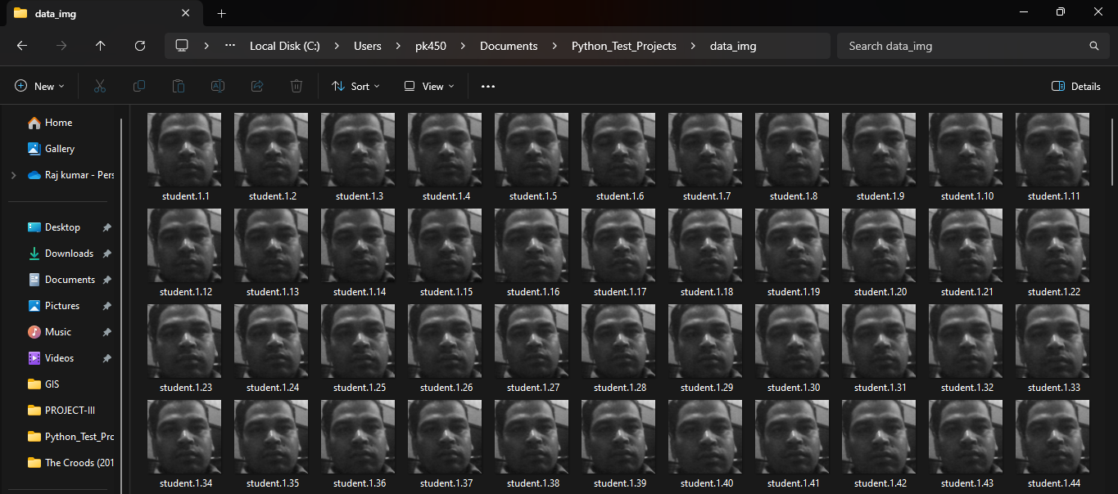

**Figure 11: Chapter 4.3 Data\_Image**

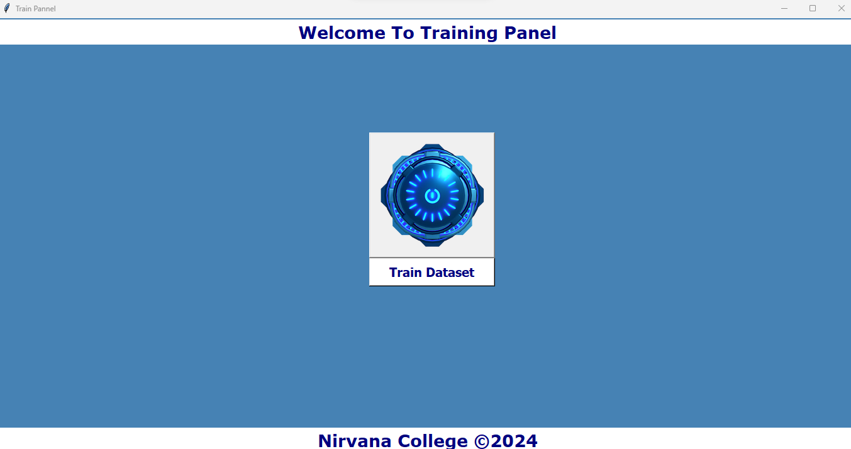

**Figure 12: Chapter 4.3 Train\_Image**

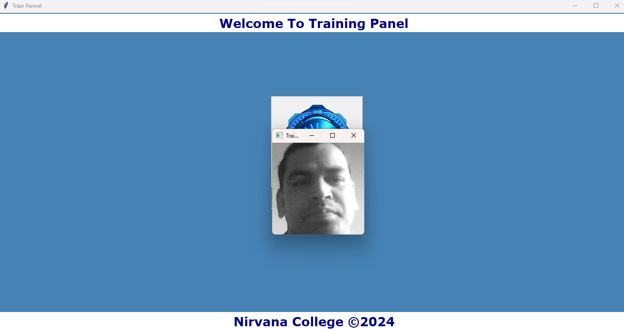

**Figure 13: Chapter 4.3 Train\_Image\_Showing**

Chapter 5: Conclusion and Future Recommendations

## 5.1. Conclusion

Finally, I have completed my project meeting all the guidance and requirements of TU. My project is on face recognition based attendance system which have many features are includes like Student’s information, attendance, attendance report, registration, training and datasets of image. And it is demo type website system which manages the attendance within the academic fields. But as looking around in Nepal, everyone is not properly using the facial attendance and somehow in Nepal, every attendance is not taken by asking name of students which consumes time and having habituate of physical noting attendance system. So I want to develop this system with many features which can be useful in academic field and can bring well systematic change in Nepal and Nepali Societies. So it is the first step for me to learn that I’m able to develop the demo type websites.

## 5.2. Future Recommendations

My project is completed with simple concept. But I want to develop it totally online server based system in the upcoming future which will be require host account like domain. I will develop it fully functional web server along with having several features like accurate time table, calenders feature, meeting scheduling, minuting features, managing time table for teachers and students that they can have the login id. The system will be not only for Teacher but it will be for students too. My system would be use in any fields like education, business, etc. The system would be compatible with any electronic devices like android mobiles, tablets, computers, etc.

# Appendices

fnam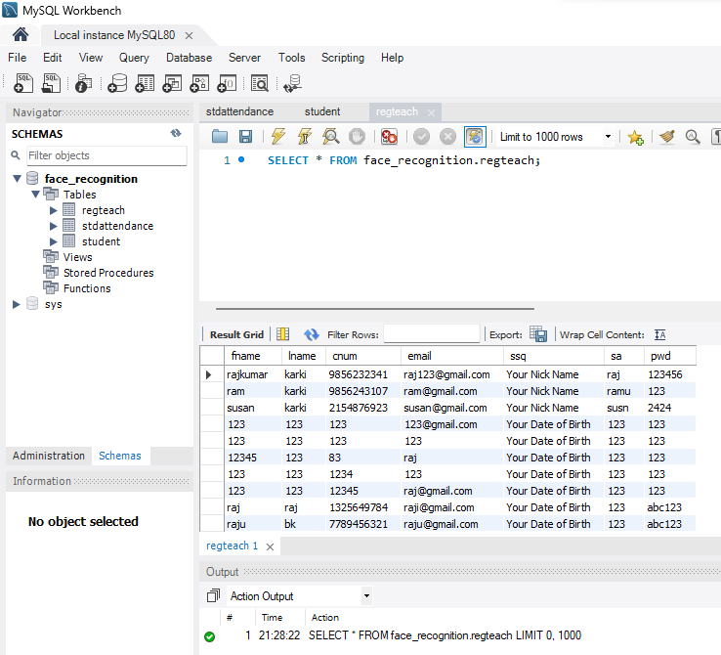

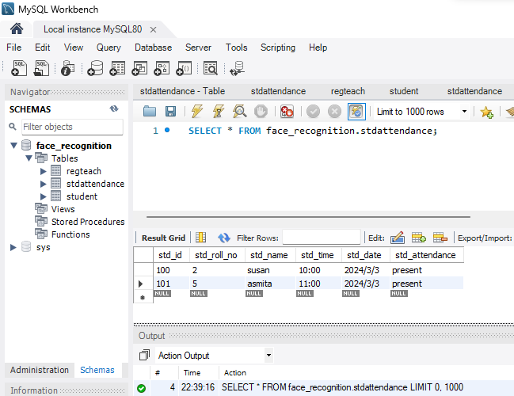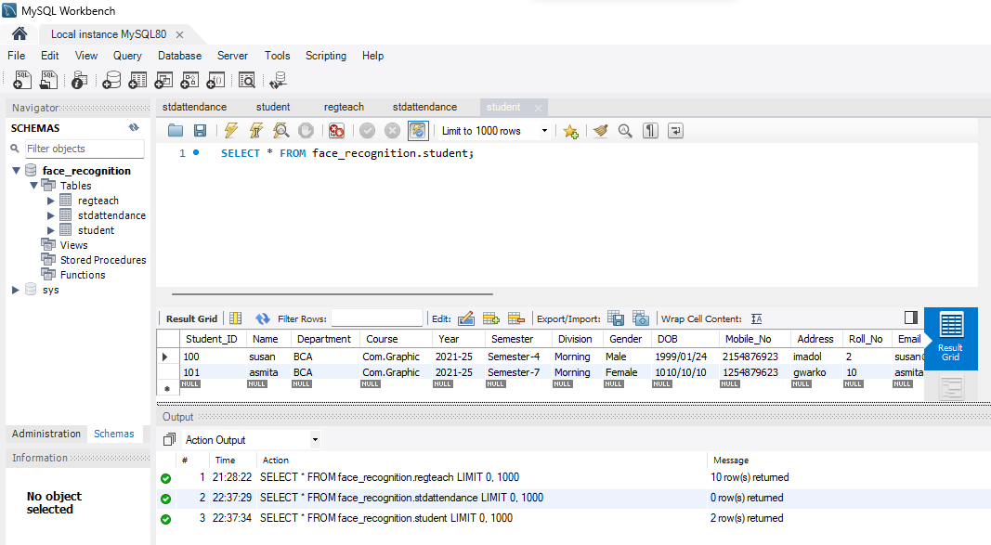

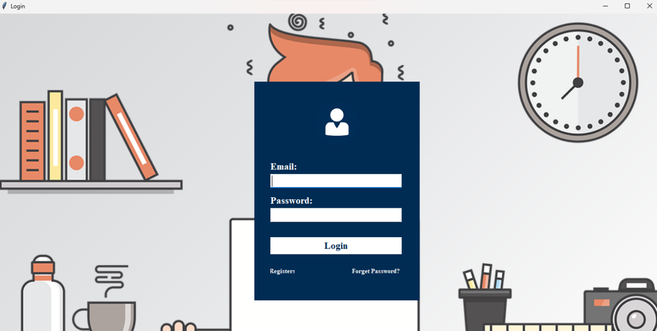

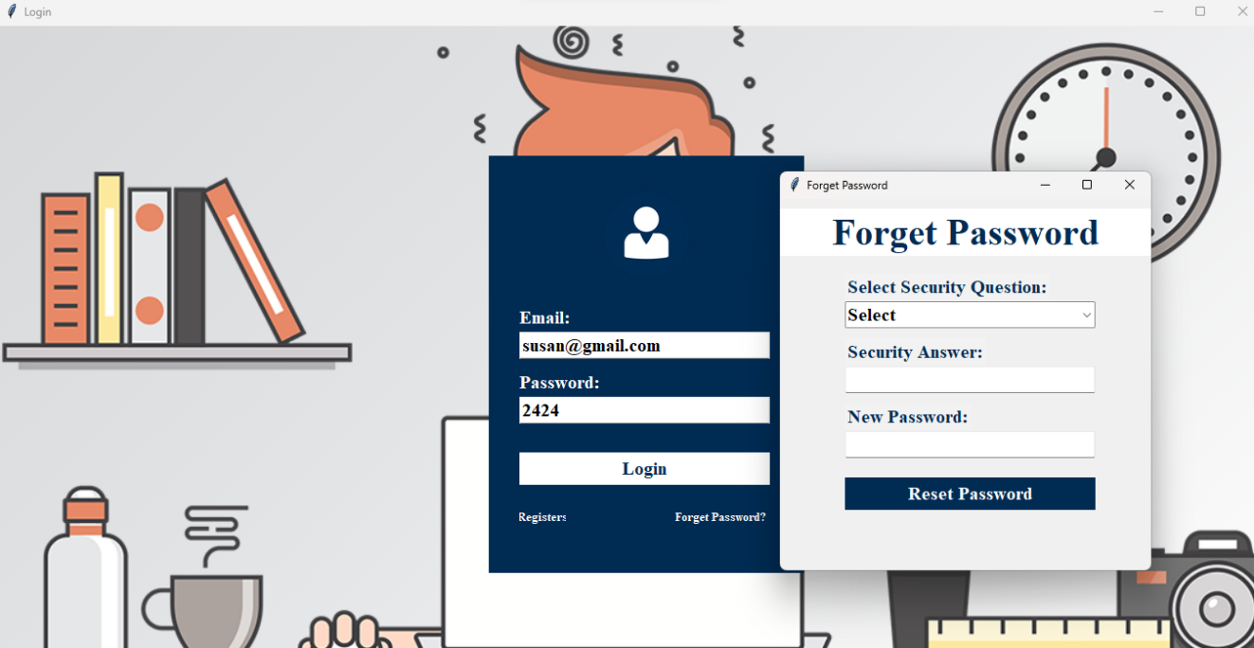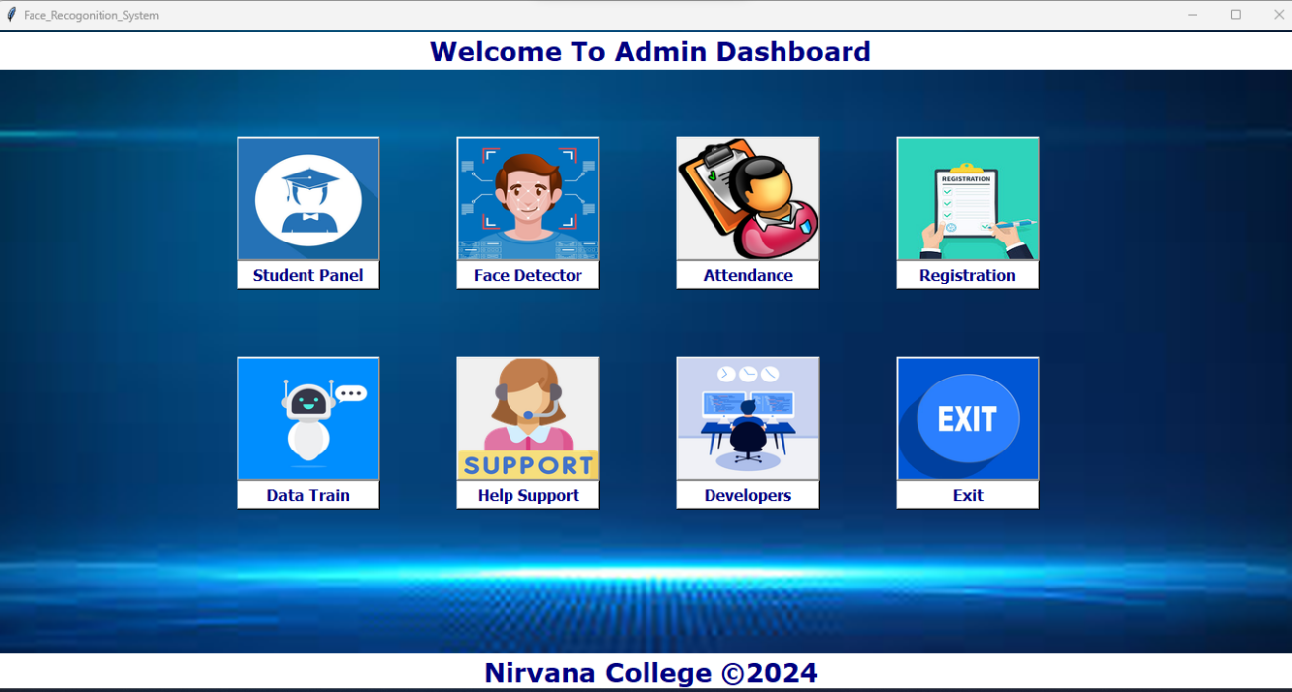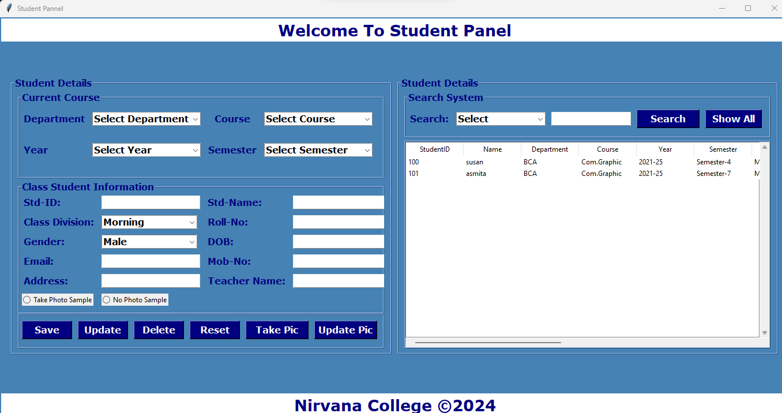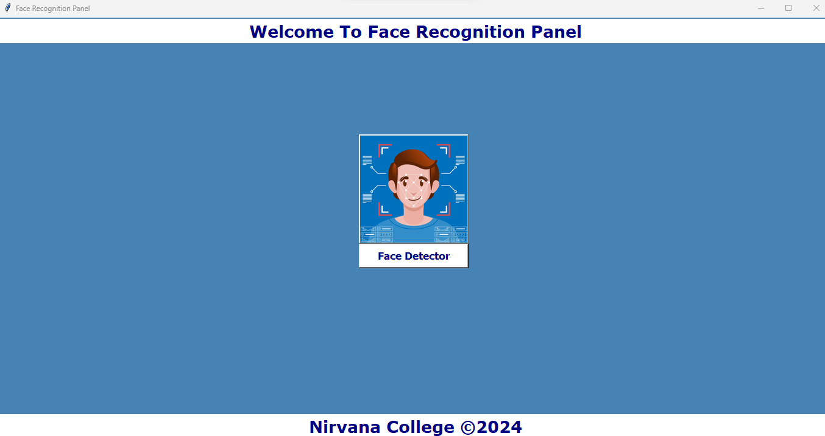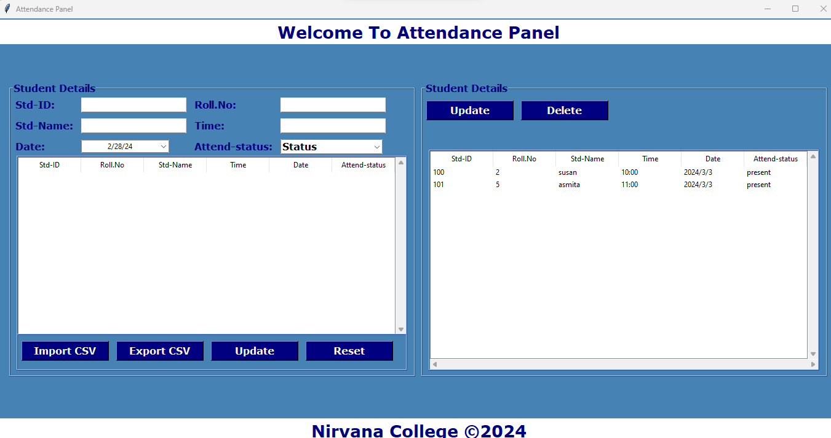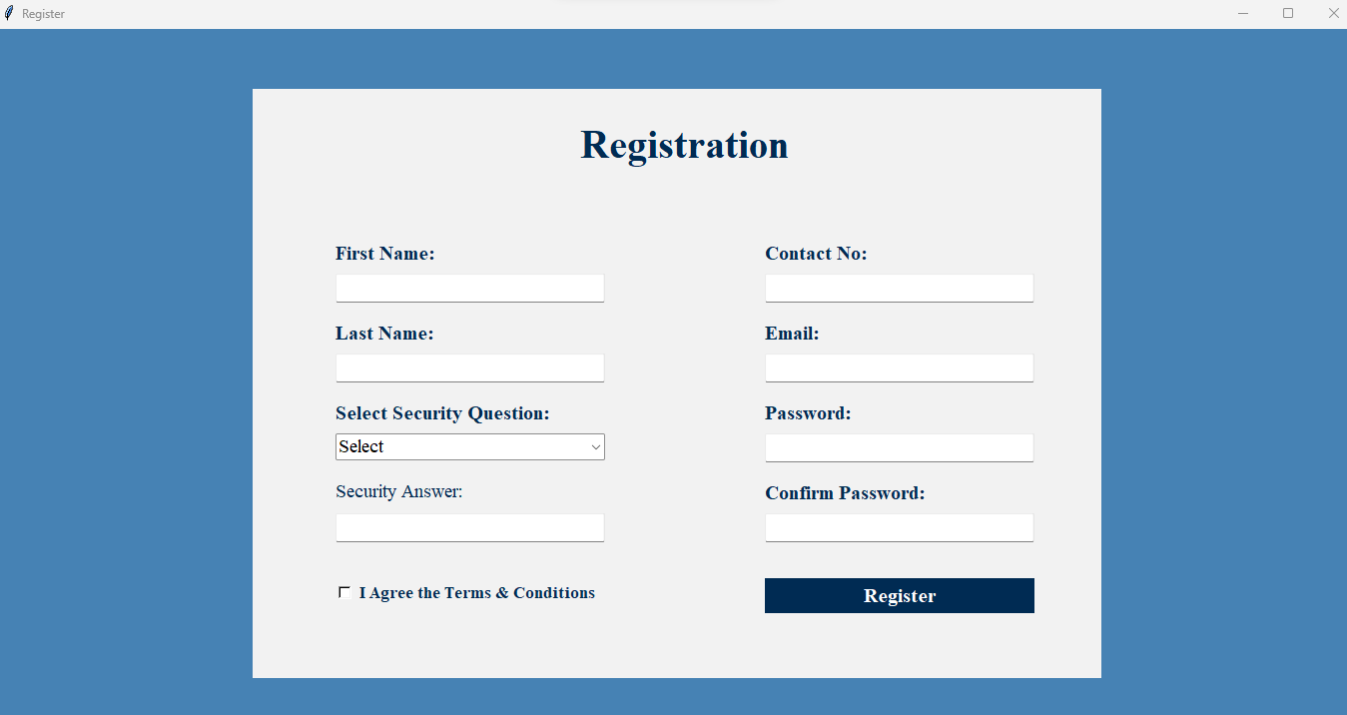





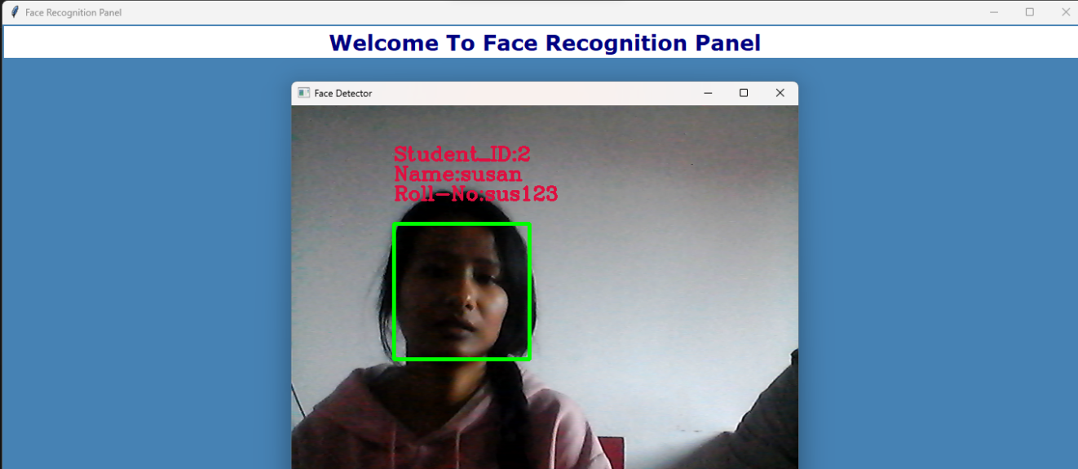

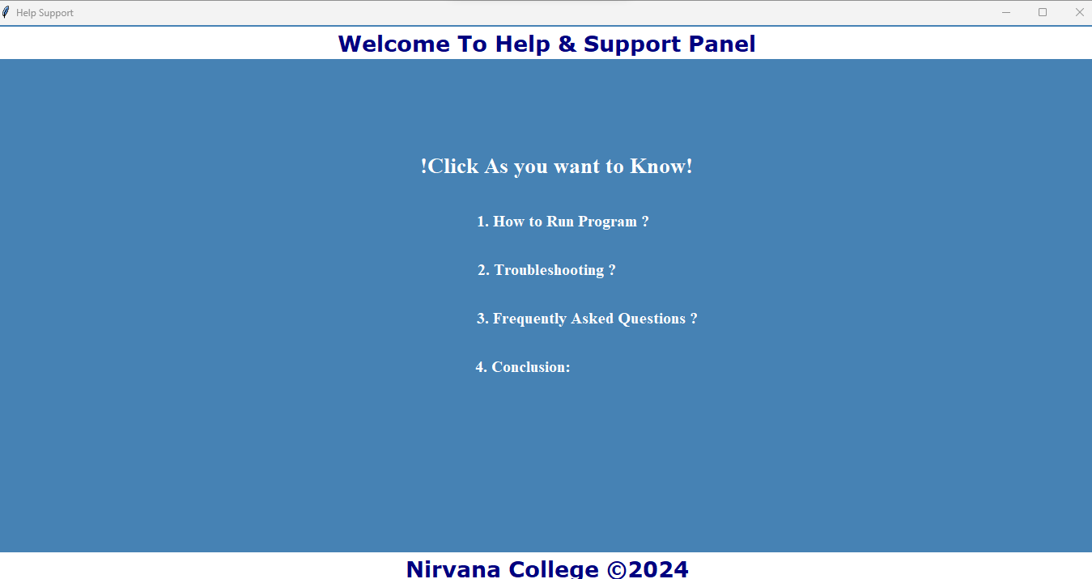

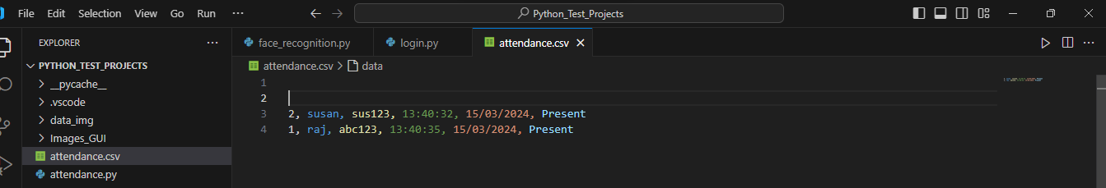

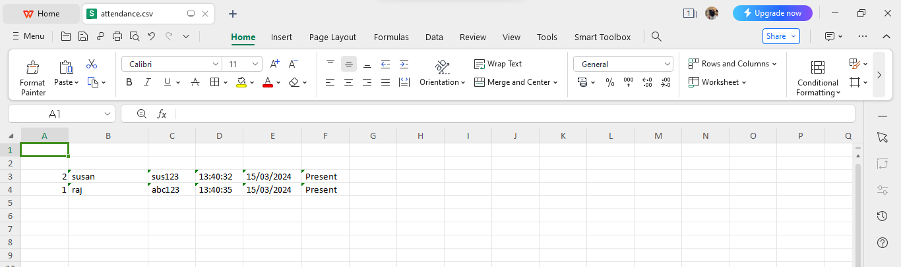

# References

1. “RFID based Student Attendance System” (Hussain, Dugar, Deka, Hannan, 2014)
2. K.SenthamilSelvi, P.Chitrakala, A.AntonyJenitha, "Face Recognition Based Attendance Marking System", IJCSMC, Vol. 3, Issue. 2, February 2014.
3. “Attendance System Using NFC Technology with Embedded Camera on Mobile Device” (Bhise, Khichi, Korde,Lokare, 2015)
4. “Fingerprint Based Attendance System Using Microcontroller and LabView” (Kumar Yadav, Singh, Pujari, Mishra, 2015)
5. Waterfall model - software engineering. (2018, March 18). GeeksforGeeks. <https://www.geeksforgeeks.org/waterfall-model/>
6. P. Singh, “Understanding Face Recognition using LBPH algorithm,” Analytics Vidhya, 12-Jul-2021. [Online]. Available: https://www.analyticsvidhya.com/blog/2021/07/understanding-face-recognition-using-lbph-algorithm/. [Accessed: 03-Jun-2024].
7. Tempus Central. (2023, August 10). The evolution of attendance management -. Tempuscentral.com; Tempus Central. <https://tempuscentral.com/the-evolution-of-attendance-management/>

## Bibliography

BibGuru. (n.d.). Bibguru.com. Retrieved March 8, 2024, from <https://app.bibguru.com/p/42709b28-ffcb-45f1-83d2-62cd7d58b89e>

*Python tutorial*. (n.d.). W3schools.com. Retrieved March 8, 2024, from <https://www.w3schools.com/python/default.asp>

*SQL tutorial*. (n.d.). W3schools.com. Retrieved March 8, 2024, from <https://www.w3schools.com/sql/default.asp>

**Supervisor Visit Log Sheets**

|  |  |
| --- | --- |
| **Log for the Time management system** | |
| Student Name | Raj Kumar Karki |
| Email Id | pk4505442@gmail.com |
| University Name | Tribhuvan University |
| College Name | Nims College |
| Supervisor Name | Nirmala Timilsena |
| Course & Code | Project-III (CACS452) |

|  |  |  |
| --- | --- | --- |
| **Meeting, Notes & Background Research** | | |
| **Date** | **Tasks** | **Signature** |
| 2024/5/20 | Submission of one page proposal with the title of the project. |  |
| 2024/6/20 | Submission of proposal of the project with the objectives, problem and solution. |  |
| 2024/7/18 | Learned to use StarUML for object,dynamic and process modelling. |  |
| 2024/8/15 | Conducted research and literature review related to the topic and learned citation. |  |
| 2024/8/30 | Began coding Face Attendance System. |  |
| 2024/9/18 | Implemented the Local Binary Patterns Histogram(LBPH) algorithm for generating detection and recognization. |  |
| 2024/10/25 | Tested and refined the recommendation algorithm with sample datasets. |  |
| 2024/11/14 | Deference of Project by Supervisor. |  |
| 2024/11/24 | Defence of Project by External Sir. |  |
| 2024/11/26 | Improving the documentation of Project. |  |